Section 6 Conclusion MB

AI
AI was used for assistance with coding and documentation creation but played a major role in the project by providing the AI opponent for the human player.
Right from the outset, it was decided that the AI agent chosen had to be a) one of the major players b) well documented, c) offer free tiers and d) work with the chosen game engine, Unity.
The field of AI changes rapidly so the project was to be written in such a way that the call to the AI API could quickly and easily be amended, should the original AI agent become unavailable for any reason.
Gemini (Google) fulfilled all of these criteria and was used in the initial versions. During the testing, in order to improve the response time, the agent was amended to Groq (backed by X/Twitter). The ease of this change vindicated our design choice.
The testing revealed that the API key was publicly available on Github so the system was amended to use Cloudflare which obscured the key and could also store user data although this facility was not implemented.
Several amendments were made to improve the response time of the call to AI, as the bulk of the delay was down to Unity, parameter size and timing of the AI call. AI had to be told quite specifically what to do and what not to do, for example, don’t pass everytime instead of playing a card, or don’t play a non optimum card.
The improved speed of the AI responses led to tokens being used faster than the available free tiers available so alterations were made to reduce the frequency, size and use of the APIs. The initial project was destined to include extra functionality, such as an option to allow the AI to be played against without it knowing which rules were enabled. The lack of free token bandwidth made this infeasible without manually creating the opponent coding within the app.
Use of external AI was not part of the initial project pitch and proved quite time consuming to implement. If the project were restarted now, serious consideration would be given to writing the code manually instead due to the complexity, unpredictability and cost.

Commercial Viability & Cost Analysis

Cost Calculation Methodology

Prices are in US Dollars as the technologies used are all US based. AI cost is based on assumption of 6,000 tokens per game using Groq production model pricing and one game per day. Fixed costs include Unity Pro ($170), Cloudflare ($5) and maintenance ($100). Maintenance costs comprise approximately $40 for application updates and bug fixes, $25 for backend/API maintenance, $15 for monitoring and support, and $20 for platform compliance and updates (total $100/month) Total is $275/month. Break-even is therefore 184 regular monthly users.

Break-even Analysis
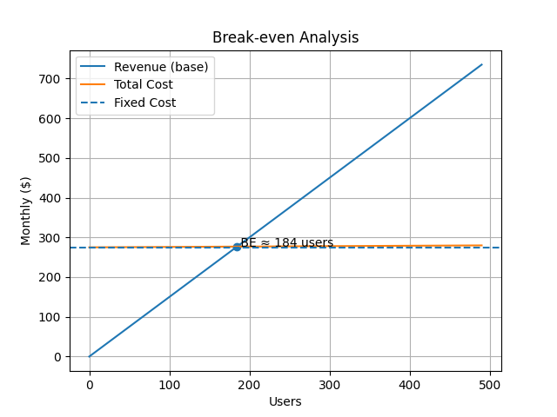

Sensitivity Analysis
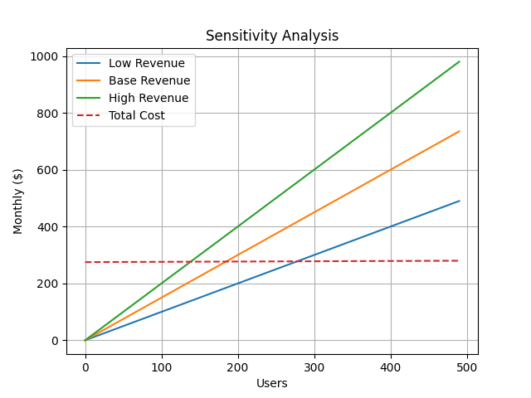

Assumptions and Limitations
Revenue per user is estimated at $1.50/month. Real-world performance may vary significantly depending on user acquisition and engagement and also the methods utilized for income, i.e. based on downloads only, in app purchases, product placement, advertising or any combination thereof.

Commercial Risk and Alternative Strategy
While the AI-driven model offers flexibility and scalability, it introduces a recurring operational cost that may not be justified at lower user volumes. In a competitive mature market, this app would need to stand out to achieve the required income and a strategically viable alternative is the implementation of a deterministic, rule-based system to replace AI decision-making. This approach would reduce AI costs to zero but not affect the other costs. AI could be used to create the code for this manual adaptation.

